“Volunteering is the ultimate in democracy. You vote in elections once a year, but when you volunteer, you vote every day about the kind of community you want to live in.” Marjorie Moore  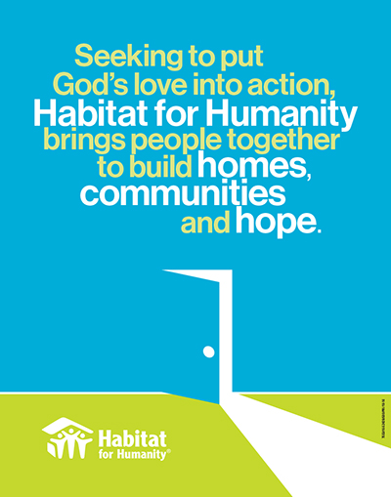 | Habitat for Humanity of East and Central Pasco County  37220 Meridian Ave, Dade City, FL 33525 |  | 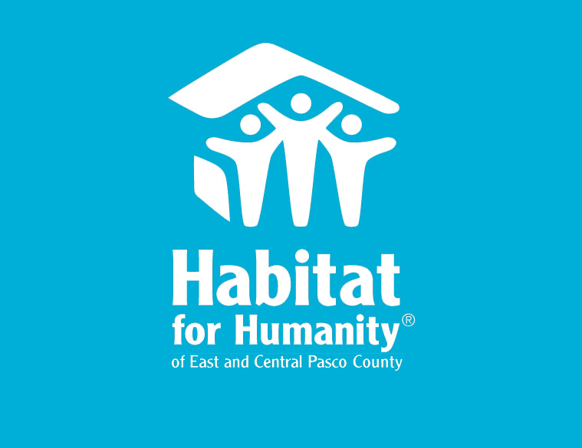  - 40 ways YOU can help Habitat for Humanity change the lives in a family  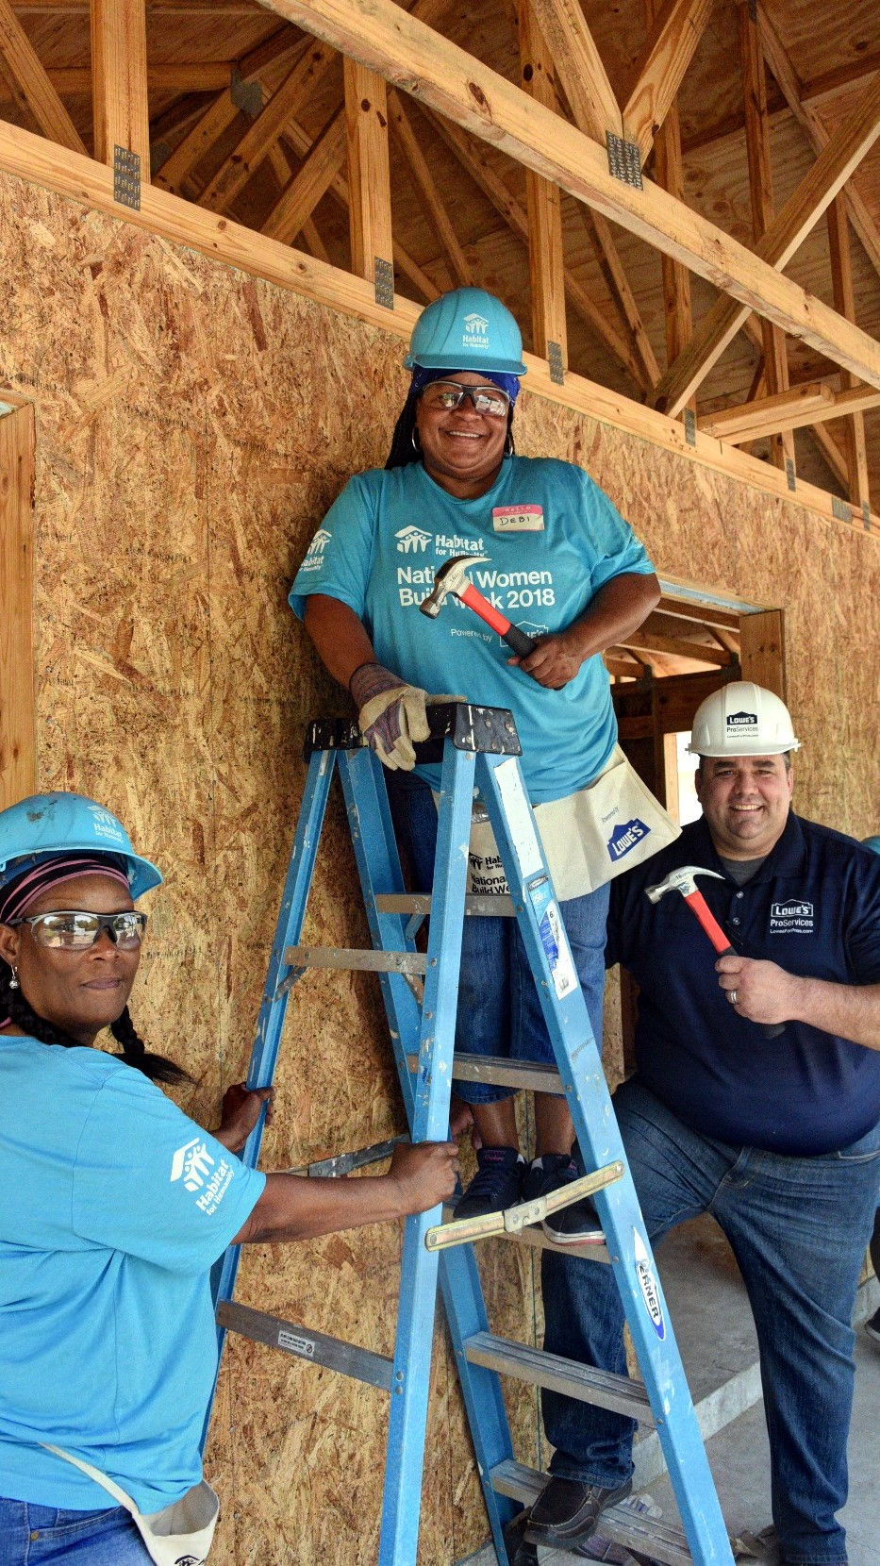

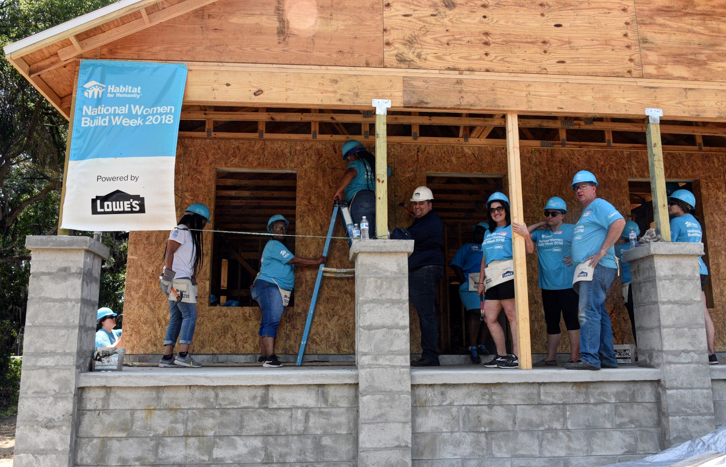  Leadership on the Job Site  - Serve as a “Crew Leader” for one house  - Meet and Greet Volunteers  - Issue out equipment and tools  House Construction  - Siding  - Painting  - Finish carpentry  - Cabinetry  - Countertops  - Site Prep/Lot clearing  - Excavation  - Install windows and doors  - Framing/rough carpentry/salvage  - Clean up  - Installing Floors/Tile  - Landscaping  - Hurricane straps and bracing  - Roofing  Construction Support  - Errand runner for build sites  - Help organize construction pavilion and tool trailers  - Seek donation of building materials and tools  - Seek and prepare meals for build site volunteers | Homeowner Involvement  - Recruit future home owners  - Serve as a “family partner”  - Help setup and conduct “HOME information” meetings  - Help setup and conduct “pop up” info events  Friend Raising  - Help setup and conduct “pop up” info events  - Help setup and conduct volunteer recognition activities  - Event photographer  - Social media outreach  Church relations  - Help coordinate church relations activities  - Help coordinate church sponsorship of build projects  - Encourage activity within your church  - Be an ambassador for Habitat at your church  - Pray for our mission to eradicate poverty housing around the world  Office Work  - Data entry  - Update and maintain database  - Front desk hospitality/general office duties  ReStore Support  - Serve as clerk in the ReStore  - Assist with pick up of donations  - Assist with the receiving area at the ReStore  - Assist with donation processing at the Restore  - Assist with setup/upkeep of departments  - Assist with soliciting donations and scheduling donation pickup  Focus on What You Do Best  You might try a summary of competitive benefits at left and a brief client success story or some of those glowing testimonials here in the middle. | No experience is necessary to volunteer on our work sites; although we love our skilled construction volunteers too! There are many tasks that only require a willingness to learn and work with others. On-site construction is the most popular of Habitat’s volunteer opportunities. We make every effort to incorporate all volunteers regardless of skill; however, you must be at least 16 years old to work on an active construction site. Grab a hammer and join in!  Where Do I sign up?  Individuals may sign up by calling (352) 567-1444 or emailing Jere Ferguson at jferguson@habitatpasco.org  Groups that would like to reserve a build day should contact our office 30 days in advance minimum  Contact Us  Habitat for Humanity of East and Central Pasco County  37220 Meridian Ave, Dade City, FL 33525  (352) 567-1444  volunteer@habitatpasco.org  www.habitatpasco.org

